CS106A Midterm Reference Sheet Spring 2018

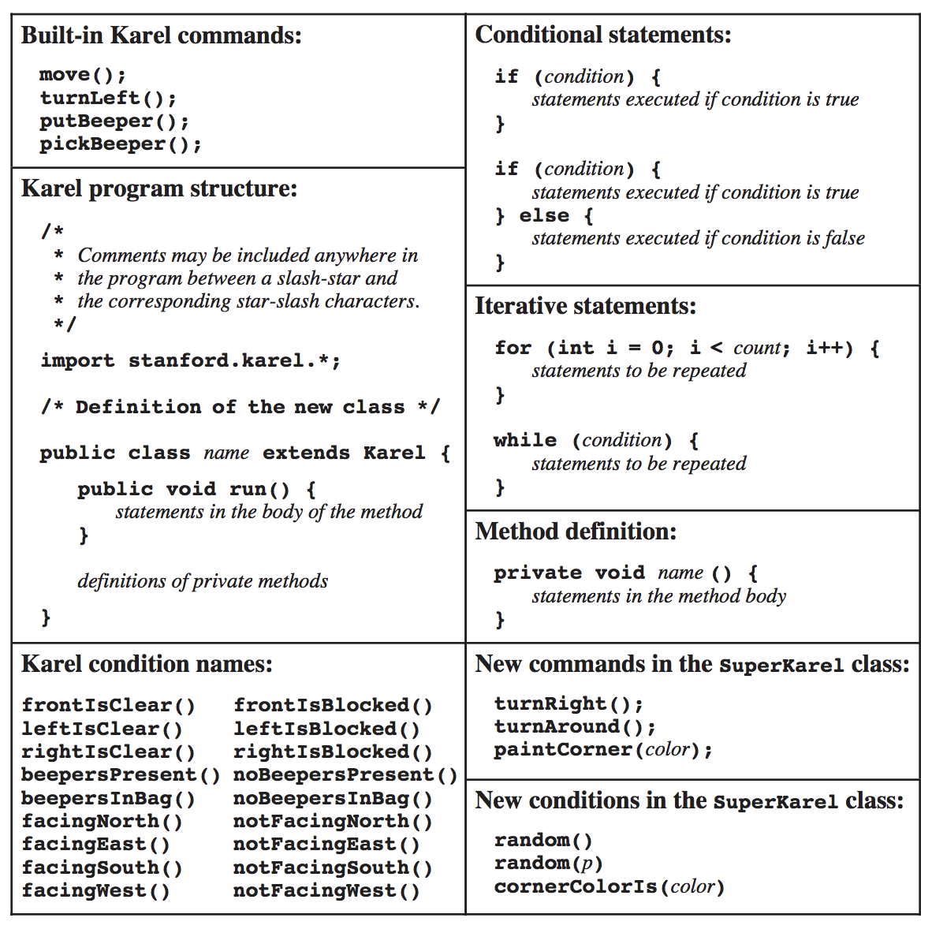

**MouseEvents:**

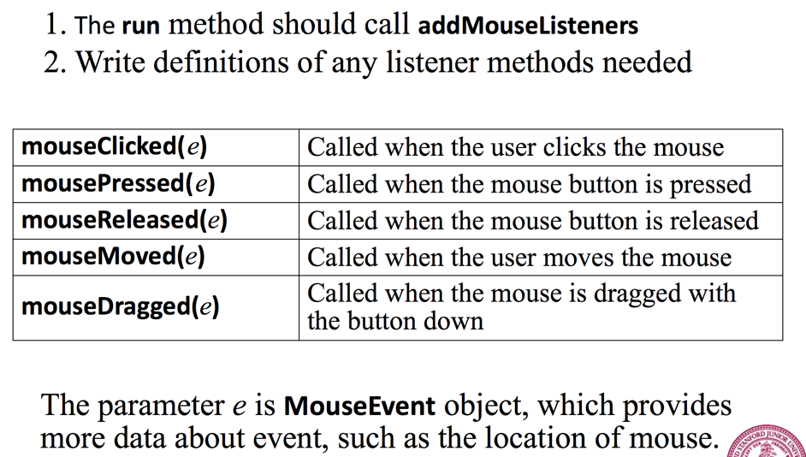

**Graphics:**

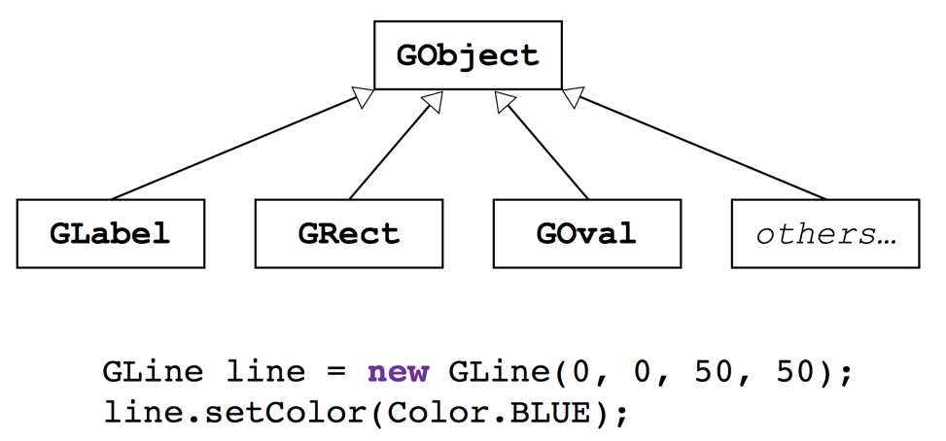

All GObjects have:

- a constructor that takes dimensions and, optionally, location

- setColor(color)

- setLocation(x, y)

- move(dx, dy)

- ability to be added to a GCanvas using add()

- ability to be detected using getElementAt()

**Character methods: String methods:**

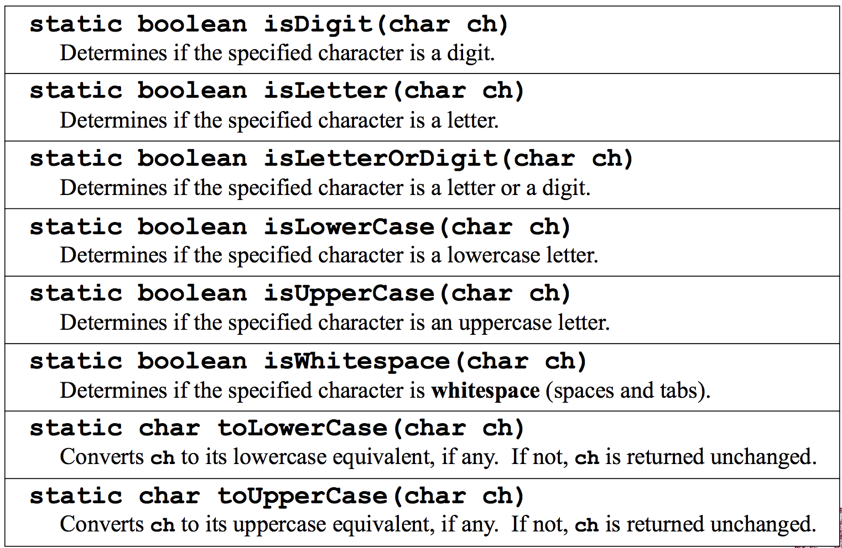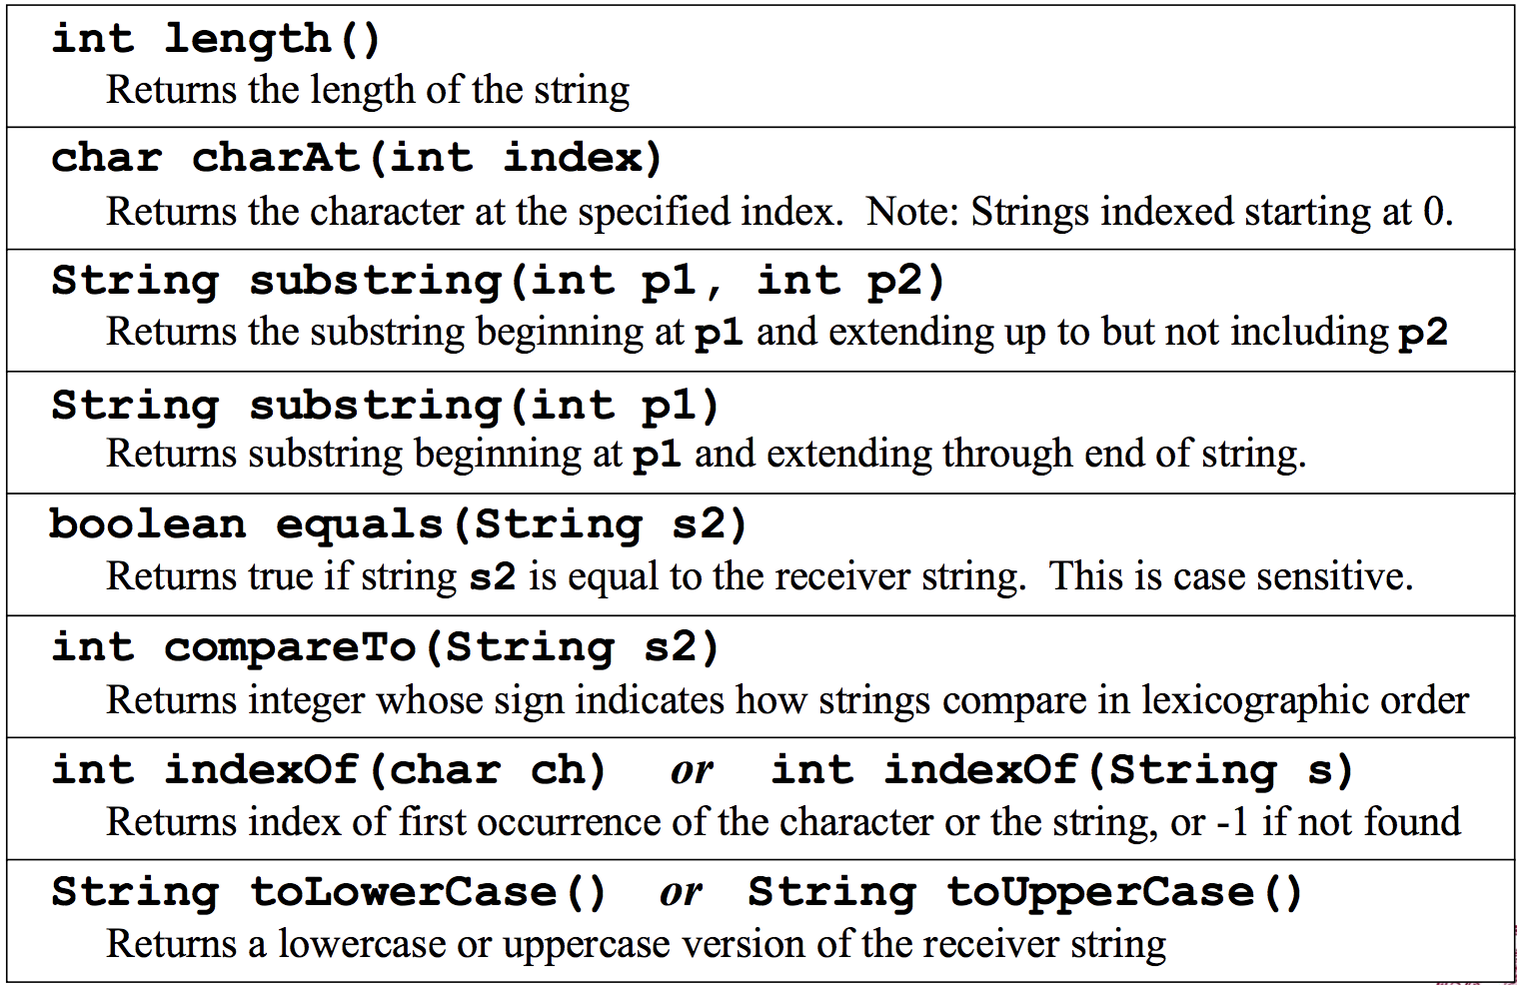

**Trace Problem (#2) for reference:**

*nothing written here will be given credit; make sure your answers are in BlueBook.*

public class Trace extends GraphicsProgram {

public void run() {

int w = 0;

// first

w = moreWidth(w);

GOval a = new GOval(w, w);

println(w);

// second

w = moreWidth(w);

GOval b = new GOval(w, w);

println(w);

// experiment 1

highFive(a);

println(a.getWidth());

// experiment 2

oneTwoThree(b);

println(b.getWidth());

// experiment 3

moreWidth(w);

println(w);

}

private void oneTwoThree(GOval q) {

q.setSize(123, 123);

}

private void highFive(GOval x) {

x = new GOval(5, 5);

}

private int moreWidth(int y) {

y = y + 10;

return y;

}

}